SPAOM 2022 ABSTRACT (Style: Title)
Willebrord Snellius¹, Robert Hooke², Bernardino de Sahagún^{3,4} (STYLE: AUTHORS)
E-mail : bernardino.sahagun@remoa.net (STYLE: email)
- Leiden University, Rapenburg 70, 2311 EZ Leiden, The Netherlands
- Gresham College, Barnard's Inn Hall, Holborn, London EC1N 2HH, United Kingdom
- Colegio de Santa Cruz, Plaza de las Tres Culturas, Tlatelolco, México
- Universidad de Salamanca, 37008 Salamanca, Spain
- STYLE: AFFILIATION

KEY WORDS: STYLE: KEYWORDS. Living cells, super-resolution, quantitative microscopy, correlative light-electron microscopy, light-sheet fluorescence microscopy, functional imaging
STYLE: MAIN TEXT. All contributions to the conference (abstracts, posters and oral presentations) will be in English. A limited number of contributed papers covering original work will be accepted for oral presentation. All abstracts must follow this template and be camera-ready for direct reproduction. Styles are provided within this template.
The abstract must be typeset for A4 (210x297mm) with 25mm lateral and top and bottom margins. The paragraphs should be fully justified. All images and figures must be included within the page limit.
The main text should be typed in 12-point, Calibri, single-spaced only. The title of the talk and authors' names, affiliations, complete return addresses, and e-mail address must appear on the top at the pages typed in 12-point bold and centred. Author affiliations, figure captions and references should be typed in 10-points. Cite references at the end of the abstract.

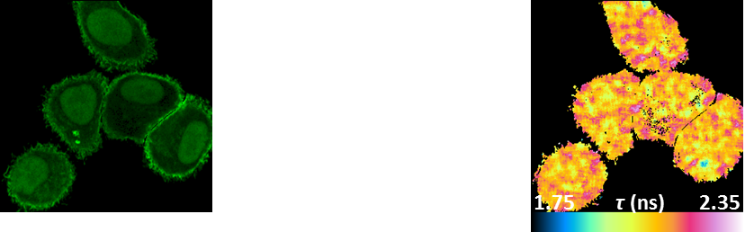
Figure 1. STYLE: FIGURE CAPTION. Images may be set inside a table to allow easier formatting

[1] STYLE: REFERENCES A. Author; B. Coauthor, and C.C. Collaborator, Title of the paper, Journal in Italic, 1, 123-456 (1999).
[2] S. Kawata, Book title underlined, Chapter 1. (Publisher, City, 1999).

